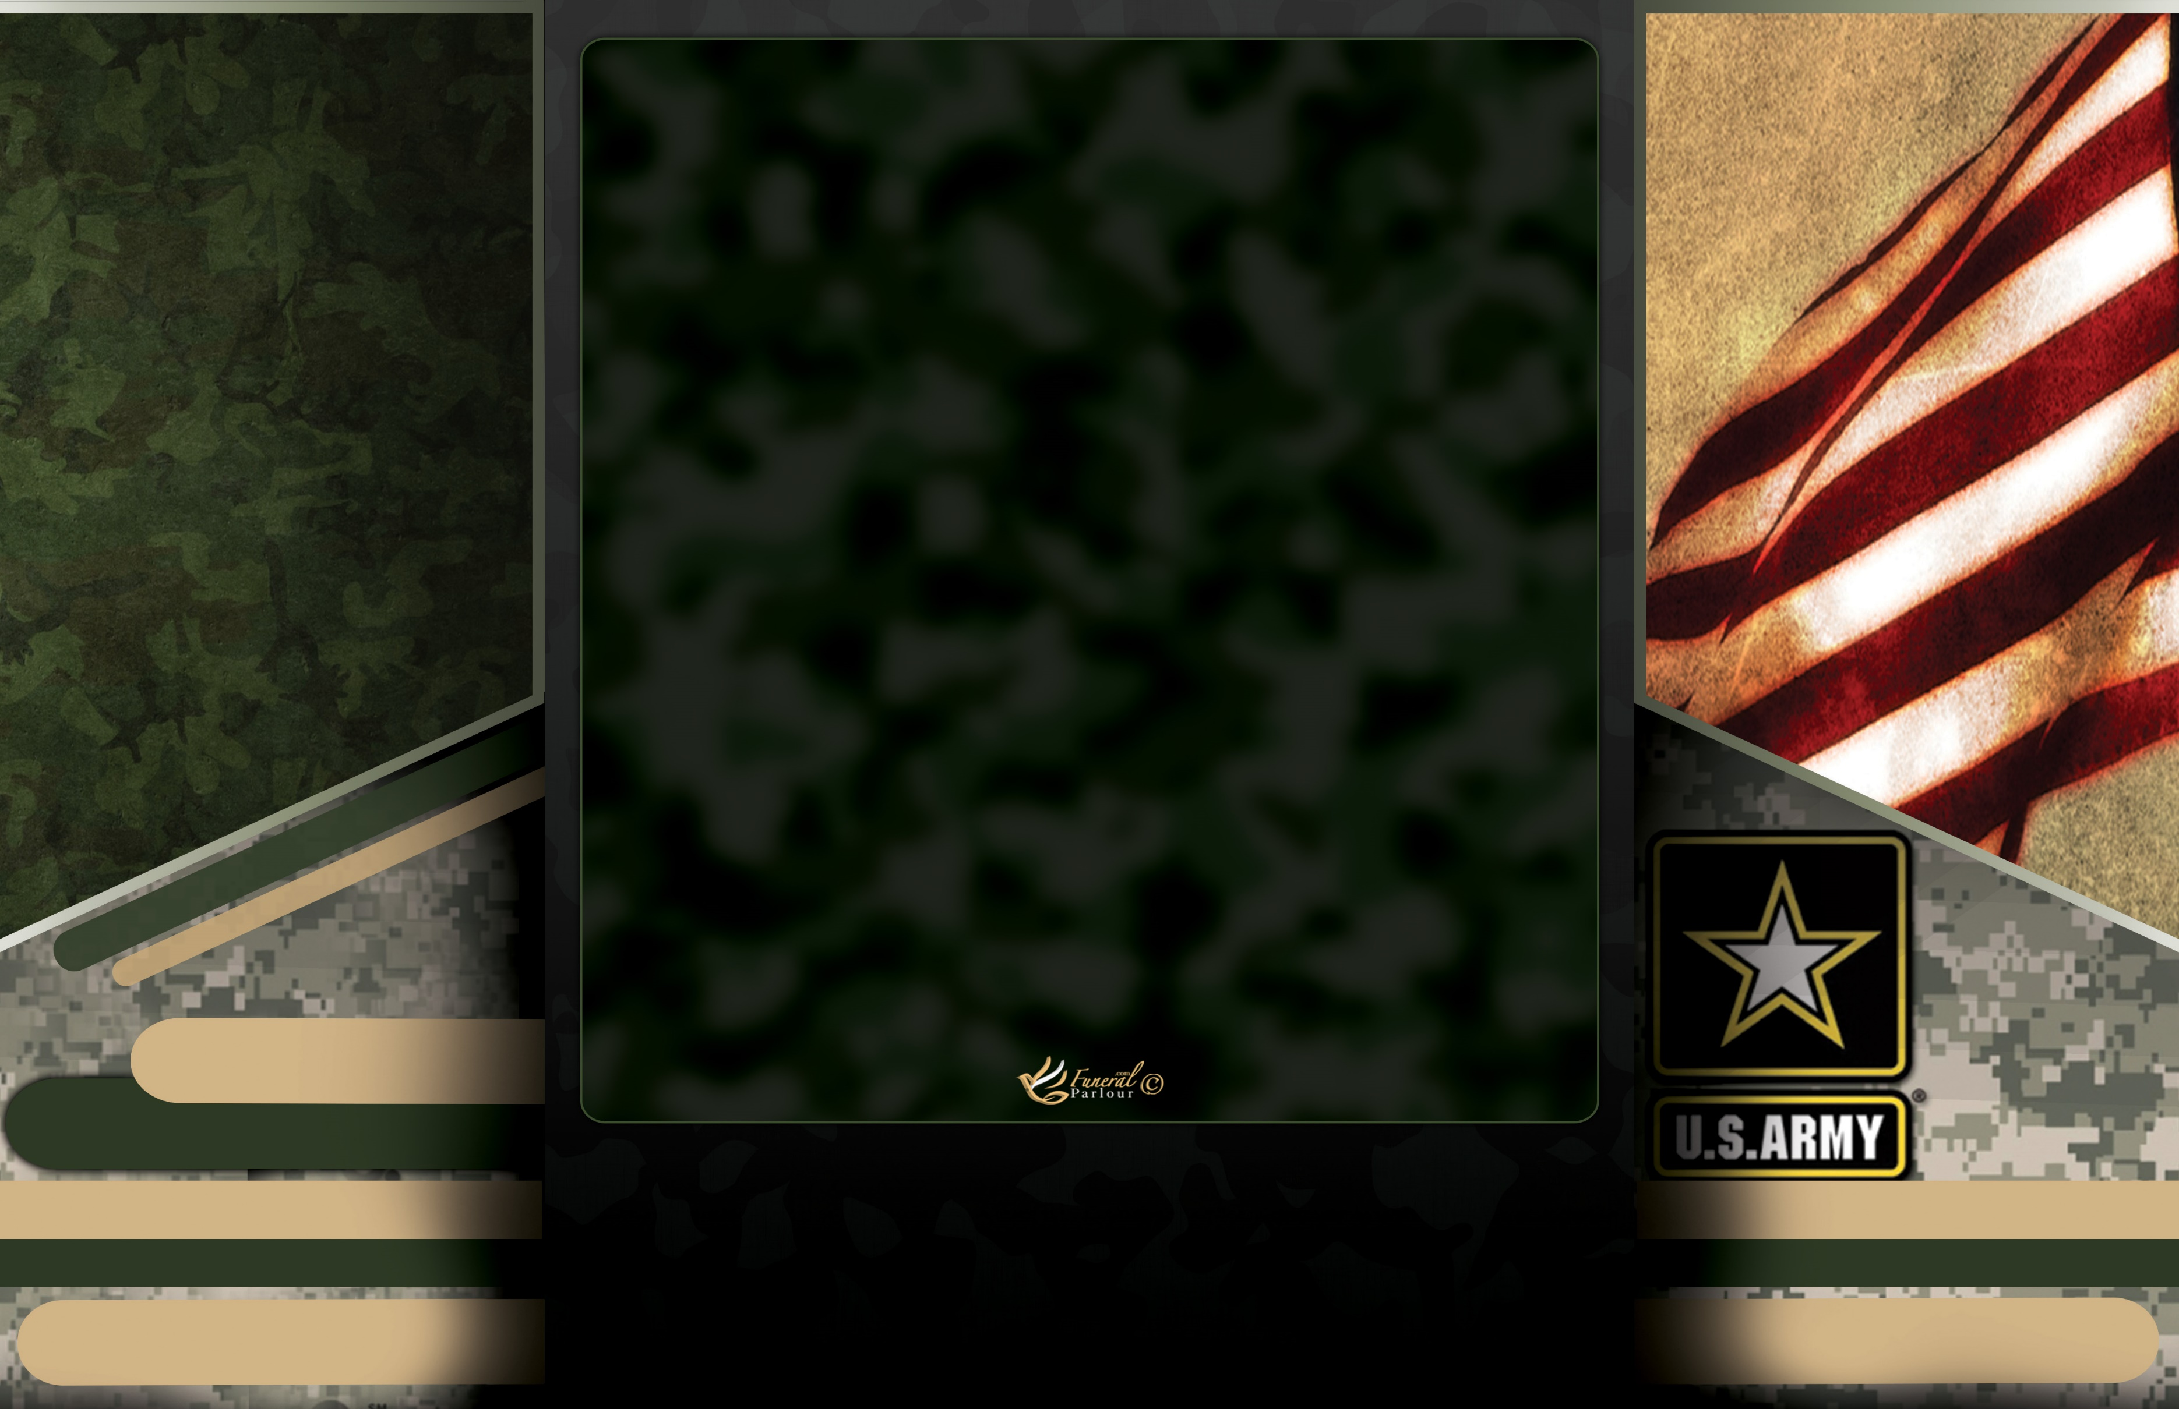

Honorary Pallbearers

Roshell Young | LeJerrious Jones | Roscoe Johnson Sr. | Eric Richardson | Macorian Saffold

Marion Richardson III | Rasberry Givens Jr. | Bobby Richardson | Demetrius King

Active Pallbearers

James Young III | Kevin Landers | Martonio Landers | Donnie Landers Jr.

Demond Richardson | Shad Arnold| Nickolas Thompson | Antwoine Miller Sr.

Interment

Mud Creek Cemetery

101 Mudd Creek Cemetery Road

Lakeland, Georgia 31635

Acknowledgements

"We would like to express our deepest gratitude for the outpouring of love and support during this difficult time. Your kind words, comforting meals, and thoughtful gestures have been a source of strength for our family as we remember and celebrate the life of our beloved loved one. Your support has brought us comfort and peace. Special thanks to the Arnold and Williams family.”

- With Sincere Thanks,

The Landers Family



# of

Sears Street Church of God By Faith

Douglas, Georgia 31533

Ruling Elder H.N. Tuner, Eulogist

Sunset: October 9, 2024

Sunrise: July 28, 1961

Landers Sr.

James Anthony

**Memory**

Saturday, October 19, 2024

11:00 AM

# In

**Loving**

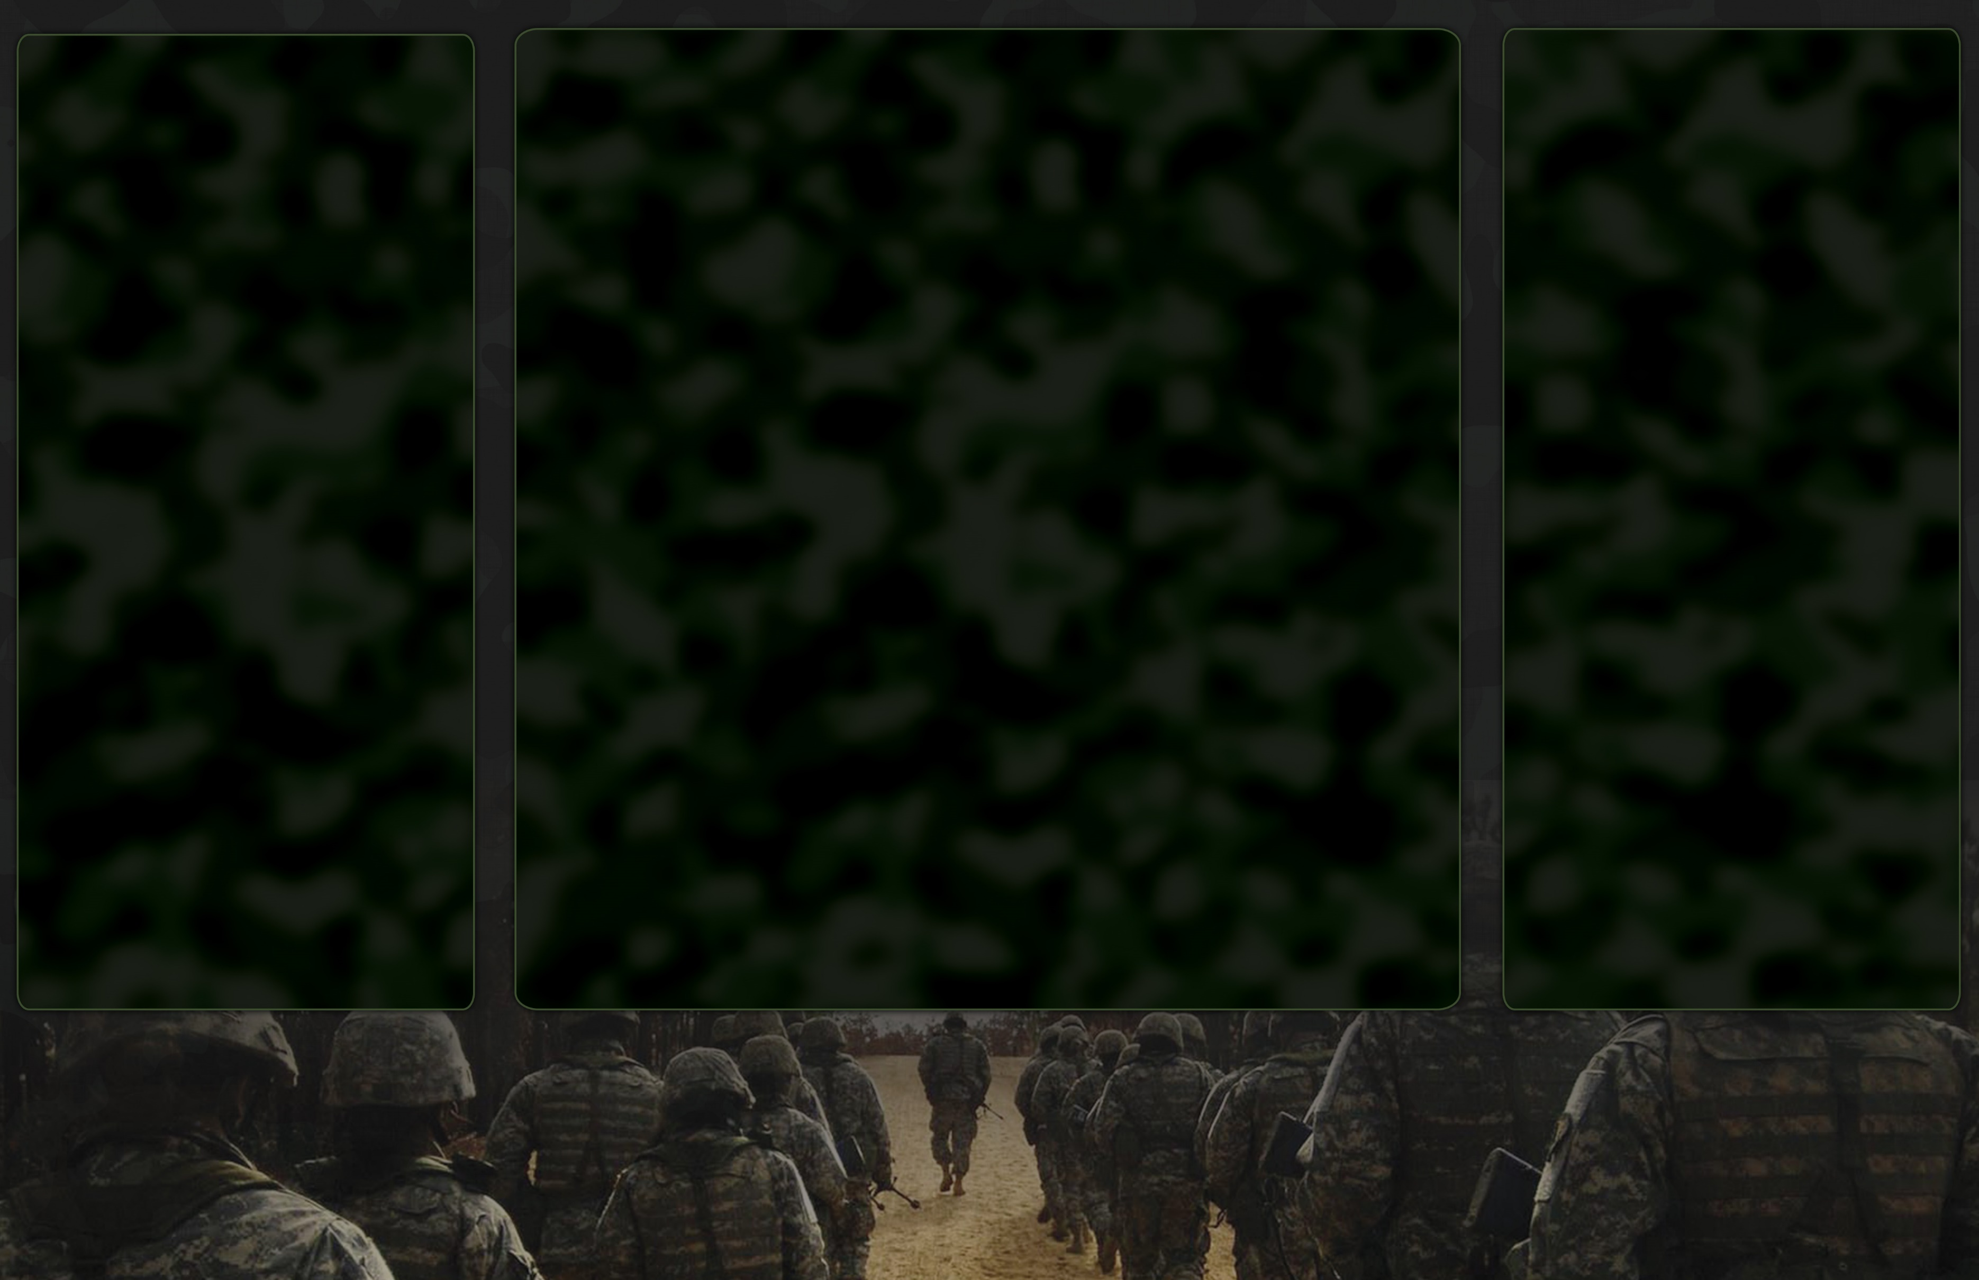

Order of Service

Life Reflections

Precious Memories

Processional………………….Family and Ministers

Final Glimpse

Invocation…………Reverend Lynette Richardson

Solo………...Minister Kentaiwon Carter-Durham

Scripture Reading

Old Testament……....Pastor Paul Thomas

New Testament..…Bishop Craig Johnson

Solo………………………………..…………Rashad Sims

Reflections………..Please Limit To Two Minutes

Anyone Desiring to Speak

Solo…………Minister Kentaiwon Carter-Durham

Eulogy………………..…..Ruling Elder H.N. Turner

Military Honors

Committal Service

Benediction

Mr. James Anthony Landers, Sr. was born on July 28, 1961, in Pearson, Georgia, to the late Earlie Sr. and Ruby Lee Landers. He passed away on October 9, 2024.

He attended school in Pearson but completed his education in Douglas, Georgia. In 1981, James proudly enlisted in the United States Army, serving his country with honor.

Upon returning home from his military service, James was united in holy matrimony to Barbara Lynette Richardson. James was preceded in death by his parents, Earlie Sr. and Ruby Lee Landers, and two brothers, Earlie Landers Jr. and Donnie Landers Sr.

James has fought the good fight, ran the race, and won the battle. On October 9, 2024, God knelt down and whispered, "Come Home, my child,” no more pain, no more sickness. Obediently, he surrendered his soul; he’s no longer dreaming the dream; he now lives the dream with his Heavenly Father.

James leaves behind cherished memories with his beloved wife, Barbara Landers of Douglas, Georgia; his five children: Saadia (Lydell) Riley of Pooler, Georgia, James (Kasey) Landers Jr. of Douglas, Georgia, Cameron (Deidra) Landers of Haines City, Florida, Denorval Byrd of Baxley, Georgia, and Kadrecia Lester of Hawkinsville, Georgia. He is also survived by his brother, Tony (Karen) Landers; his sister, Lisa (Bruce) Dennis; his sister-in-law, Betty Landers; and a host of grandchildren, nieces, nephews, cousins, and friends.

